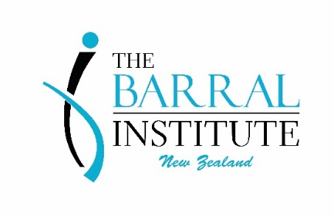
Upcoming New Zealand Courses 2020/2021

All courses will be held at our new permanent venue – 11/75 Peterborough Street, Christchurch
Course | Course Dates | Teacher | Early Bird & Repeat  Special Rate Ends | Cost | Course Length
Visceral Manipulation: Abdominal 2 - VM2 | 19th – 22nd November 2020 | Rosie Greene | 8th October 2020 | EB $945, Full $1120, Repeat $690 | 4 Days
Visceral Manipulation: Abdominal 1 - VM1 | 11th – 14th February 2021 | Damian Kitcheman | 31st December 2021 | EB $945, Full $1120, Repeat $499 | 4 Days
Neural Manipulation: Neuromeningeal Manipulation - NM1 | 10th – 12th April 2021 | Annabel MacKenzie | 30th January 2021 | EB $860, Full $1020, Repeat $620 | 3 Days
Neural Manipulation: Neuromeningeal Manipulation - NM2 | 14th – 16th April 2021 | Annabel MacKenzie | 3rd February 2021 | EB $860, Full $1020, Repeat $620 | 3 Days
Visceral Manipulation: Abdominal 2 - VM2 | 11th – 14th September 2021 | Rosie Greene | 31st July 2021 | EB $945, Full $1120, Repeat $690 | 4 Days
Visceral Manipulation: The Pelvis – VM3 | 16th – 19th September 2021 | Rosie Greene | 5th August 2021 | EB $945, Full $1120, Repeat $690 | 4 Days
Visceral Manipulation: VisceroEmotional Relationships - VM6 | 29th – 31st October 2021 | Rene Assink | 17th September 2021 | EB $1060, Full $1220, Repeat $820 | 3 Days
Neural Manipulation: Brain & Cranial Nerve Manipulation - NM4 | 2nd – 4th November 2021 | Rene Assink | 21st September 2021 | EB $1060, Full $1220, Repeat $820 | 3 Days

Course spaces can be reserved using the $200 deposit for Early Bird & Repeat specials
(check end dates for these special rates).

